Other information

Getting here
Buses: 102, 184, 299, W3
Underground: Bounds Green
Overground: Alexandra Palace/ Bowes Park

Our location
Google co-ordinates: 51.599041, -0.137317
Plus codes: 9C3XHVX7+J3
What3Words: parks.frames.bucket
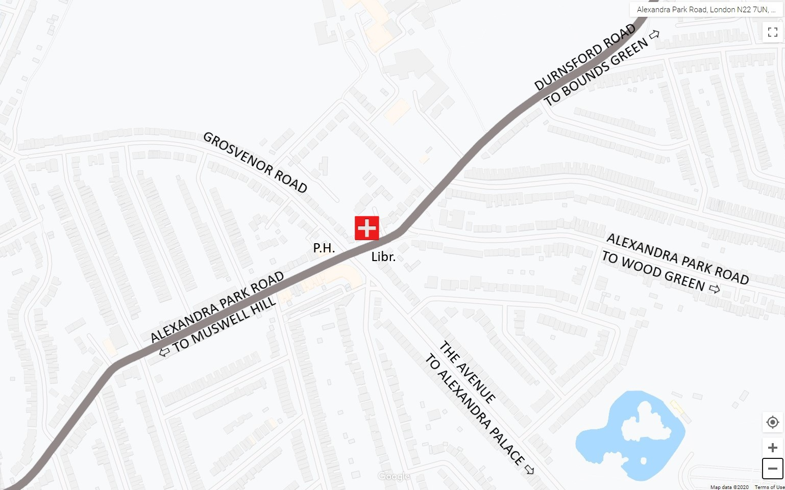

Access For Disabled
The surgery has disabled access and toilet facilities. Consulting rooms are on two levels – please inform staff if you have difficulty with stairs.
We have a Loop for people with hearing aids – Please ask reception.

Parking
We wish our forecourt to be used by patients with a disability or bringing small children. There is additional on-street parking in the neighborhood, with no control zone. Please beware that the library car park is for their staff only.

Violence
We treat everyone with respect and we ask you to respect the surgery.
We have a Zero Tolerance policy towards violence. The surgery is monitored by CCTV. Police will attend violent incidents.

8

Updated 2023-03-08
125 Alexandra Park Road, London N22 7UN

INFORMATION LEAFLET

“Where all roads to health meet”
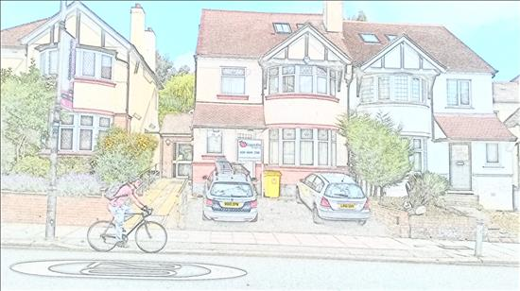

Telephone 020 8888 2518
GP Hub 0330 053 9499 (see inside page)
Out of hours 111 (for emergencies)
Email alexandrasurgery@nhs.net

Website www.alexandrasurgery.com
eConsult https://alexandrasurgery.webgp.com/
Online access https://patient.emisaccess.co.uk/


This leaflet is also available as A5 booklet in English.

www.facebook.com/alexandrasurgery.co.uk



1 March 2023

About Alexandra Surgery

We are an NHS general medical practice in North Central London.
CQC inspection (published on 22 August 2022)

Overall rating: Good
For detailed report please see
https://www.cqc.org.uk/location/1-494016382

Joining the practice

Anyone can register with a GP, including people who are temporarily here or do not have legal immigration status.
Your previous NHS number, copy of ID and address will be helpful (to avoid misspellings), but if you do not have these it does not stop you.

Our practice area
Most of our patients are from the N22, N10, and N11 post codes.
You can find a map on our website.
GP practices have the discretion to register people living outside their practice area. For patients living far away from the area, GP may not be able to visit them at home.

Registration process
At present you need to fill paper forms. You may ask reception for the forms, or download from our website and print out. Please ensure you fill in all details, otherwise the NHS will reject it.

The registration forms include a questionnaire, so we know about your medical history and any medication you take regularly.
We offer new patients a health check with our Nurse or Health Care Assistant.

We also encourage you to agree to receiving mobile text messages and email from us. (You can change your mind any time)
On behalf of the NHS we ask whether you consent to Summary Care Records being shared within the NHS.

After the NHS accepted you, you may ask for the code to unlock online access.

2

SMS text messages
Please register your mobile number so we can send you appointment reminders and any urgent test results.
If you do not wish to be disturbed in this way, do let us know and we can bar the computer.

Confidentiality – NHS Code of Practice (2003)
We ask for information about you so that you can receive the best possible care and treatment. We keep this information, together with details of your care, to ensure that your doctor or nurse has accurate and up to date information.

Everyone working in the NHS has a legal duty to maintain the highest level of confidentiality about patient information. We disclose details only if necessary to arrange your care, for example referral to hospitals.

Summary care records
These are intended for sharing within the NHS to ensure you receive best care everywhere you go (for example, A&E department).
If you wish to opt out of this, please contact the practice.

Comments and Complaints
We are always looking for ways to improve our services. If you experience any problems or have suggestions, kindly put these to our Practice Manager, Ms Abhi Sivananthan, by
- telephone (you may leave a brief message with receptionists)
- letter or fax
- e-mail to alexandrasurgery@nhs.net
She will acknowledge your comments and respond to them as soon as possible.

When making a complaint, you may request support from the NHS Advocacy Service. Their advice is free, independent and confidential.
Helpline: 0300 330 5454
Textphone: 0786 002 2939
Fax: 0330 088 3762
Email: nhscomplaints@voiceability.org

7

Repeat Prescriptions
If you are on regular medication, your doctor may authorise repeats on your computer record. You may request periodic supply without seeing your doctor, for a maximum of 6 months.

Prescriptions can be sent safely and rapidly by electronic channel to a pharmacy of your choice. Please indicate your preferred pharmacy.
Please allow 72 hours for a repeat prescription to be processed.

Repeat prescriptions can be requested in several ways:

- Via your online account
This is the quickest method as it goes directly to the doctor’s inbox. Please register for electronic access to repeat prescriptions. If you need help to set up, please ask reception.

- By eConsult
You may request repeat prescriptions, consultations and certificates.

- Handled by your preferred pharmacy
Some local pharmacies will request for your prescription on your behalf. Please provide signed consent at your preferred pharmacist.
It may take extra time for transit of these requests.

Paper methods – may take an extra 2-3 days, as they need to be transferred into the computer system and double checked for errors:

- Return the list attached to your last prescription
- Please select items you require and drop the list in the special box, or send by post to the practice.
- If you wish to receive your prescription by post, please enclose a stamped self-addressed envelope.

We do not accept prescriptions requests by telephone, to reduce the risk of error.
We make an exception for some housebound or disabled people.

6

Our Practice Team

Doctors
Patients may consult with any of the doctors.
Dr SIVANANTHAN, Athee (female) – lead doctor
Dr CORRIETTE, Nicole (female) Dr PATEL, Jason (male)
Dr RAGUPATHY, Sinthuja (female) Dr SULTANA, Ayesha (female)
Dr SHANTI KUMAR, Muttu (male)
More doctors may join us from time to time.

Physician Associate
Mr Brian BENNETT

Practice Nurse
Ms Dhurata Halili

Clinical Pharmacists
Mr Hinesh Patel, Ms Rola Ibrahim, Ms Raiesa Ahmed

Wellbeing Coach
Ms Mine Oguz

Social Prescriber / Link Worker
Ms Fardowsa Sharif

Practice Manager Administors / Supervisors
Ms Abhirami Sivananthan Mrs Yoges Sivananthan
Mr Krish Sundaralingam

Receptionists/ Healthcare Assistants/ Ethnic Health Officers
Mr Ajanthe Anura Ms Dorina Radanovics
Mr Ishtiaq (Russell) Khondaker Ms Katerina Kontopyrghou
Ms Ladan Mohamed Ms Malisha Wickramasinghe
Ms Mathi Vettivelu Ms Safiya Mohamed
Ms Yasemin Tosunlar Huseyin Mr Yasin Farah

Clinic attaché
Dr Steve Hiew Dr Gaja Thanathas

Our team members speak other languages, we also use professional Language Line – please ask us to arrange.

3

Surgery Opening Times
MONDAY 8.00am – 6.30pm
TUESDAY 8.00am – 6.30pm
WEDNESDAY 8.00am – 6.30pm
THURSDAY 8.00am – 6.30pm
FRIDAY 8.00am – 6.30pm
Extended hours: in the evenings / on weekends by arrangement

Consultation Times
Consultations are by appointment only.
We have a mix of face-to-face and telephone appointments.
Some can be booked in advance, others become available on the day.
We do our best to ‘fit in’ emergencies, especially for young children – please explain the problem to reception.

To arrange an appointment, please telephone, or come to our reception. You may also request via eConsult. Some appointments are available to book online.

Home visits & Emergencies
We ask you to ring in as early as possible if a home visit is required. Giving us more details about the condition will help the GP to assess the urgency of the visit.

GP Hub
http://gp.haringeyccg.nhs.uk/gp-news-items/gp-access-hubs/66428
Appointments with other GPs / nurses are available out of hours:
MON – FRI 6.30pm – 8.30pm
SAT – SUN 8.00am – 8.00pm
BANK HOLIDAYS 8.00am – 8.00pm
To book, please telephone 0330 053 9499 during these hours.

When the surgery is closed
Call 111 if you need urgent medical attention.
Call 999 or go to A&E department for life threatening conditions.

Self Care – dealing with minor illness and injury
You may find simple advice online, or from your local pharmacy.
http://www.haringeyccg.nhs.uk/Services/self-care.htm

4

Special Services
We support you to prevent ill health, or help optimise your treatment if you have existing problems.
- Minor surgery
- Referral to Community Pharmacy Consultation Scheme (CPCS)
- Long term conditions management (for example asthma, diabetes)
- Family planning (including intra-uterine device fitting)
- Child development check and Children’s immunizations
- Routine health checks
- Bowel, cervical, and prostate cancer test
- Weight management

Laboratory tests (blood, swab, urine, faeces, nail clipping)
Our staff send test requests directly to the hospital system.
You can collect sample bottles and test forms from reception.
They will help you book a blood sample appointment, or you may book yourself by phone or online.
Other samples can be left in the collection box near the entrance.

Blood test results
Please log into your NHS App/ Online Access account, or call reception or to find out your test results.
If they require urgent treatment the doctor may telephone you or send a text message.

Improving services - Patient Participation Group (PPG)
Our PPG, set up in 2011, consists of volunteer patients, our practice managers and the GPs.

We engage patient representatives in face-to-face group meetings, by email for personal discussion, and via social media.

The discussions of our PPG and the outcomes are published annually on our website:
www.alexandrasurgery.com
(Look for the link Patient Group on the right side of the home page)

Please telephone, write or email to Abhi, our Practice Manager, if you are interested in contributing to the group.

5

